**Networking**

Class --

**Lecture --**

**Router (Hardware)**

**.**



**Lab Objectives:**

* CISCO IOS.
* Introduction to router.
* Router memory components.
* Interfaces.
* Router power on/Boot up sequence.
* External Components of a 2600 Router.
* Internal Components of a 2600 Router.
* Computer/Terminal console connection.
* Modem connection to console/AUX port.

**Cisco ios**

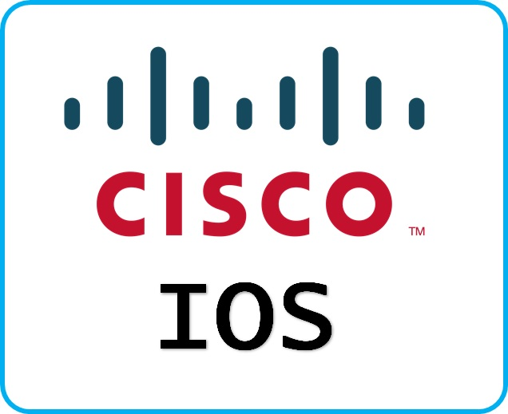

***Cisco technology is built around the Cisco Internetwork Operating System (IOS), which is the software that controls the routing and switching functions of internetworking devices.***

***A solid understanding of the IOS is essential for a network administrator.***

**Introduction to router**

***A router is a special type of computer. It has the same basic components as a standard desktop PC. However, routers are designed to perform some very specific functions. Just as computers need operating systems to run software applications, routers need the Internetwork Operating System software (IOS) to run configuration files. These configuration files contain the instructions and parameters that control the flow of traffic in and out of the routers. The many parts of a router are shown below:***

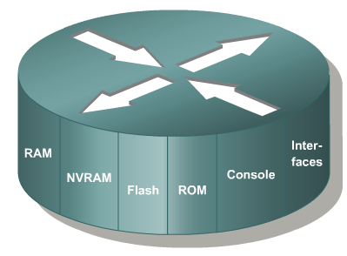

**Router memory components**

***ROM - Read Only Memory – Bootstrap/POST***

***FLASH Memory - IOS Images are kept here***

***- Erasable reprogrammable ROM***

***- Contents are kept on Power down or reload***

***RAM - Random Access memory***

***- Routing Tables***

***- Running Configuration***

***- Contents are lost on reboot***

***NVRAM - Start up configuration***

***- Configuration Register***

***- Contents are kept on reload***

**ROM**

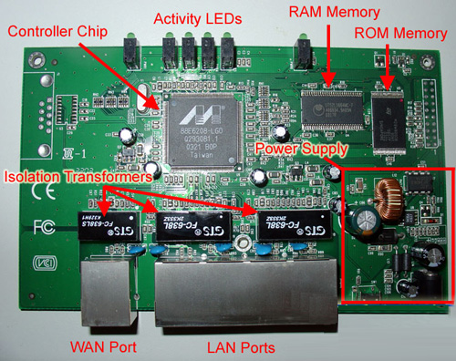

***Read-Only Memory***

***ROM has the following characteristics and functions:***

* ***Maintains instructions for power-on self test (POST) diagnostics***
* ***Stores bootstrap program and basic operating system software***
* ***Mini IOS***

**RAM**



***Random Access Memory, also called dynamic RAM (DRAM)***

***RAM has the following characteristics and functions:***

* ***Stores routing tables***
* ***Holds ARP cache***
* ***Performs packet buffering (shared RAM)***
* ***Provides temporary memory for the configuration file of the router while the router is powered on***

***Loses content when router is powered down or restarted.***

**NvRAM**

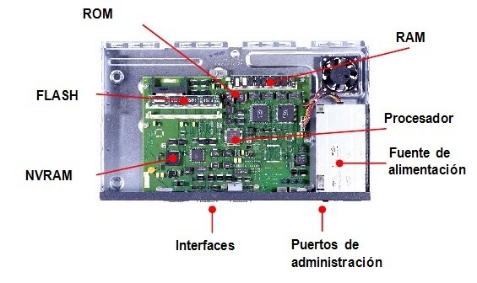

***Non-Volatile RAM***

***NVRAM has the following characteristics and functions:***

* ***Provides storage for the startup configuration file***
* ***Retains content when router is powered down or restarted***
* ***Configuration Register – 16 bit register which decides boot sequence***

**flash**



***Flash memory has the following characteristics***

***And functions:***

* ***Holds the operating system image (IOS)***
* ***Allows software to be updated without removing and replacing chips on the processor***
* ***Retains content when router is powered down or restarted***
* ***Can store multiple versions of IOS software***
* ***Is a type of electronically erasable, programmable ROM (EEPROM)***

**Interfaces**

***Interfaces have the following characteristics and functions:***

* ***Connect router to network for frame entry and exit***
* ***Can be on the motherboard or on a separate module***

***Types of interfaces:***

* ***Ethernet***
* ***Fast Ethernet***
* ***Serial***
* ***ISDN BRI***
* ***Loopback***
* ***Console***
* ***Aux***

**Router power on/boot up sequence**

1. ***Perform power-on self test (POST).***
2. ***Load and run bootstrap code.***
3. ***Find the Cisco IOS software.***
4. ***Load the Cisco IOS software.***
5. ***Find the configuration.***
6. ***Load the configuration.***
7. ***Run the configured Cisco IOS software.***

***External Components of a 2600 Router***

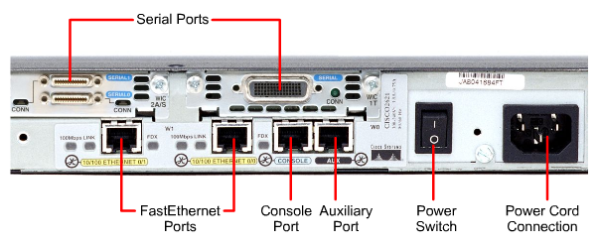

***Internal Components of a 2600 Router***

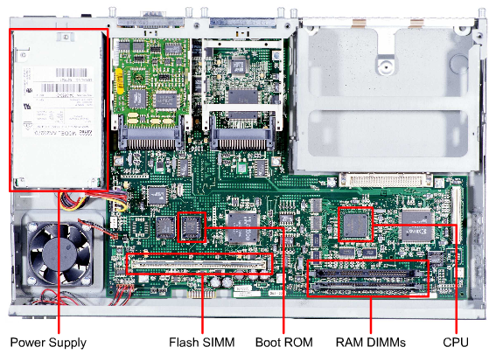

**Computer/Terminal Console Connection**

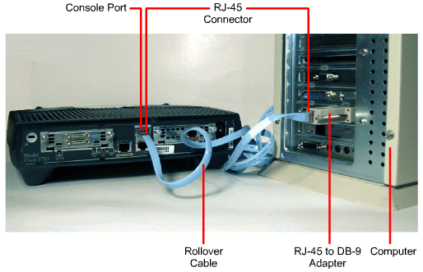

***Modem Connection to Console/Aux Port***

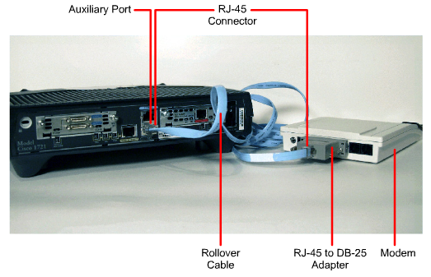



***End Of this slide***